|  |
| --- |
|  |
| The Science of Pizza  Analysing the effects of processing and formulation on food |
| Polly Burey |

|  |
| --- |
|  |

Table of Contents

The Science of Pizza 2

Pizza Components 3

Experiment 1: The effect of yeast concentration on dough size 5

Experiment 2: The importance of moisture content and water activity in tomato paste 7

Experiment 3: The effect of pH and rennet concentration on mozzarella ‘physics’ 9

The Science of Pizza

Many physical, chemical and microbiological processes go into creating the base ingredients of pizza. Today you will look at 3 different pizza components – dough, tomato paste, and mozzarella cheese, and look at the processing and composition parameters that affect their properties.

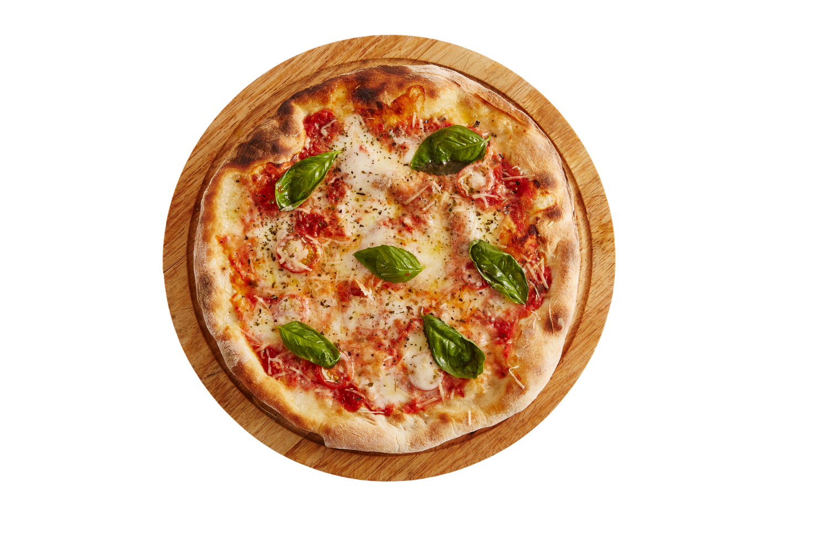

Mozzarella Structure

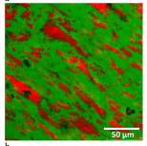

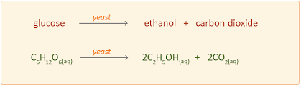

Fermentation Reaction

Mozzarella Stretchability

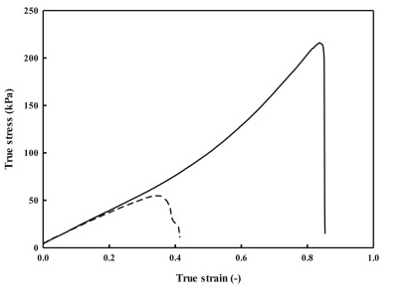

Pizza Components

***Dough***

Yeasts are microorganisms that, along with sugar, are added to dough to create a light airy texture in bread-type products. Yeasts consume sugars which they transform into carbon dioxide (CO2) and alcohol. The CO2 in particular causes the dough to rise creating a bubbly structure. Typically the more CO2 that is generated the larger the volume and the ‘bubblier’ the structure. The gluten chains make the dough stretchy.

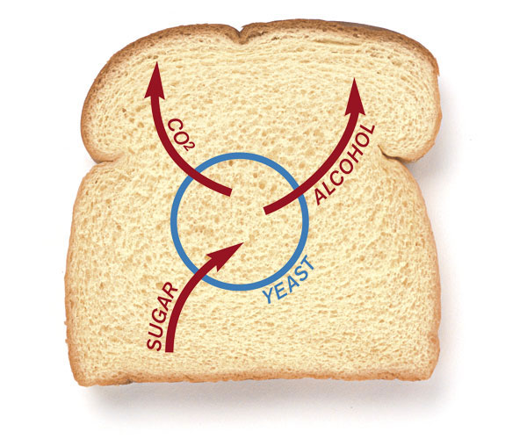

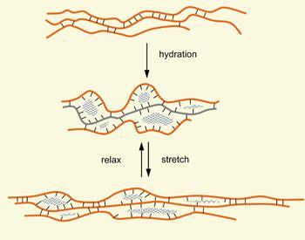

***Tomato Paste***

Concentration of food is a form of preservation, as food with lower moisture contents and water activity (i.e. water available for reaction/usage) are better to prevent microbial growth.

Liquid foods undergo concentration before dehydration and we seek to minimise damage to food constituents.

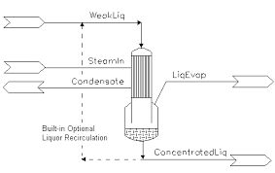Heat-sensitive foods are concentrated in low-temperature vacuum evaporators to retain proper flavour, aroma, appearance and nutritional value.

(***Why do we***

***need vacuum?***)

***Mozzarella***

Traditional Mozzarella, which is of South Italian origin, is a semi-soft cheese. It should not be rubbery and has no obvious skin/rind. Milk coagulation is traditionally achieved with thermophilic bacteria and rennet (Chymosin), however to speed the process up we will make a modification by acidifying with citric acid. Sensory attributes associated with mozzarella cheese include milkiness, stretchiness and chewiness. It is usually melted over a hot dish, such as pasta or pizza.

Mozzarella has what is called an anisotropic structure, which means the structure is directional and inhomogeneous. This is shown by elongated fat droplets (the red structures below), inside a protein matrix (the green structure below).

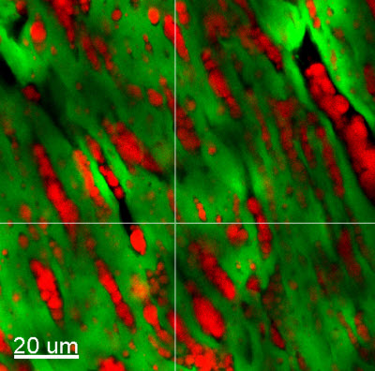

This characteristic mozzarella structure is developed during the stretching process, and is what makes mozzarella so stretchy. The process serves to align both the protein chains and the fat.

Experiment 1: The effect of yeast concentration on dough size

**Aim**

To observe the effect of increased yeast concentration on dough volume.

**Ingredients for the 3 different dough formulations**

|  |  |  |  |
| --- | --- | --- | --- |
| **Ingredient** | **Formulation 1 (g)** | **Formulation 2 (g)** | **Formulation 3 (g)** |
| Warm water (37°C) | 190 | 190 | 190 |
| Yeast | 0 | 3.5 | 7 |
| Sugar | 2 | 2 | 4 |
| Salt | 1.43 | 1.43 | 1.43 |
| Flour | 125 | 125 | 125 |
| Oil | 14 | 14 | 14 |

**Process**

1. For each formulation mix together the water, yeast, sugar and salt in a beaker with a spoon. Cover with plastic wrap and set aside for 5 minutes, or until bubbles appear on the surface.
2. For each formulation place the flour into 3 separate bowls along with the oil. When the yeast is ready, mix it in to the flour-oil mix with a spatula to form a soft dough.
3. Turn out the dough onto a floured surface (the cutting boards are fine) and knead for up to 10 minutes or until it is elastic (stretchy). Form into a ball or 2cm high disc (whichever is easier), measure the diameter and record for each ball in the table below.

|  |  |  |  |
| --- | --- | --- | --- |
| **Initial Dough characteristic** | **Formulation 1** | **Formulation 2** | **Formulation 3** |
| Dough ball diameter (cm) |  |  |  |
| Dough disc diameter (cm) |  |  |  |

1. Clean the bowls and lightly grease them with a paper towel containing a smear of vegetable oil.
2. Place each dough into its greased bowl and cover with plastic wrap. Set aside for 25-30 minutes until the dough has increased in size.
3. When all three dough batches are ready, observe size of the dough balls and re-record them in the table below. Which is biggest – form into a ball and measure diameter? Was this expected? How could this be improved?

|  |  |  |  |
| --- | --- | --- | --- |
| **Proved Dough characteristic** | **Formulation 1** | **Formulation 2** | **Formulation 3** |
| Dough ball diameter (cm) |  |  |  |
| Dough disc diameter (cm) |  |  |  |

1. Punch each dough down and knead and measure again.

|  |  |  |  |
| --- | --- | --- | --- |
| **Final Dough characteristic** | **Formulation 1** | **Formulation 2** | **Formulation 3** |
| Dough ball diameter (cm) |  |  |  |
| Dough disc diameter (cm) |  |  |  |

1. Leave dough in bowls for later.

Experiment 2: The importance of moisture content and water activity in tomato paste

**Aim**

To concentrate tomato passata (approx. 16% total solids and 7-10 °Brix) to a 38% solids content to class it as tomato paste.

**Procedure**

***Pre-Concentration Tomato Analysis***

*Measure moisture of the sample by collecting sample for microwave oven drying.*

1. Weigh a paper cup accurately to 0.01g and record the weight_______
2. Add approximately 15 g of passata and reweigh the cup and record weight_____________.
3. Place cup in the microwave and microwave on high for 10 seconds. Reweigh and record weight.
4. Repeat c) until the sample is constant weight before burning. Use the table below to keep track.

|  |  |  |
| --- | --- | --- |
| **Microwaving Time (s)** | **Weight of cup plus tomato sample (g)** | **Weight of tomato sample (g)** |
| **0** |  |  |
| **10** |  |  |
| **20** |  |  |
| **30** |  |  |
| **40** |  |  |
| **50** |  |  |
| **60** |  |  |
| **70** |  |  |
| **80** |  |  |
| **90** |  |  |
| **100** |  |  |

1. Determine moisture content as follows (should be ≈84-90%)

***=***

***Tomato Preparation***

1. Weigh the empty square baking pan and record the weight________
2. Zero the scales with the square pan on top and pass the majority of the remaining passata through a sieve and weigh into the square baking pan.
3. Record tomato passata weight _____________

**Tomato Concentration**

1. Place the square tray into the oven which will be set at 150°C. Stir with a spatula occasionally (about every 15 minutes) to prevent burn-on. Keep the tomatoes in an even layer.

Calculate below how many grams of water needs to be lost to reach the target of 38% solids, 62% water.

1. Initial grams of water in passata = weight of passata in pan x (moisture content/100) = **A** = __________ x (_________/100) =
2. Initial grams of solid in passata = weight of passata in pan – initial grams of water in passata =**B =**  ____________ - **A** ___________
3. Target final grams of tomato paste to be reduced to 38% solids = Initial grams of solid in passata/0.38 = **C** = **B**_____________/0.38 =
4. Water lost = Initial passata weight - final grams of tomato passata
5. Final weigh of pan plus tomato paste should be: Empty pan weight + Target final grams of tomato paste (calculated in Step c) )
6. At the end of the experiment, weigh all the tomato paste in the pan and check if it matches the answer calculated in Step e) above. Is this sufficient for the product to be a tomato paste? Will this deem the product suitable for longer-term storage

Experiment 3: The effect of pH and rennet concentration on mozzarella ‘physics’

**Aim**

To investigate the effect of acid and rennet content on mozzarella melt and stretch properties.

**Mozzarella Cheese-Making Procedure**

**Please only make your assigned formulation!** One will give you a beautiful stretchy mozzarella, the other will give a crumbly ricotta.

Also **please install ON 2D Cam Measure on your smartphone** (where possible)

**Ingredients**

|  |  |  |
| --- | --- | --- |
| ***Ingredient type*** | ***Formulation 1*** | ***Formulation 2*** |
| Deionised water | 117 mL | 117 mL |
| Citric acid powder | 1.35 grams | 2.7 grams |
| Liquid rennet | 0.8 mL | 1.9 mL |
| Milk | 1.5 Litre | 1.5 litre |
| Salt | 2.1 grams | 2.1 grams |

**Instructions**

1. ***Prepare the Citric Acid and Rennet:*** 
   1. Combine the citric acid powder with 95 mL of deionised water, pour and stir until dissolved.
   2. Add 20 grams of cold water to the rennet and stir
2. ***Warm the Milk:*** Pour the milk into the plastic ice-cream container. Stir in the citric acid solution. Microwave on high in 30 second bursts until the milk reaches 32°C; stir gently after each burst.
3. ***Add the Rennet:*** **Gently** stir in the rennet solution. Do not stir too vigorously or you will break your cheese structure. Time for 30 seconds and then stop stirring, cover the container and let it sit undisturbed for 7 minutes.
4. ***Cut the Curds:*** After 7 minutes the milk should have set. It should look and feel like soft tofu. If it is still liquid-y, re-cover the container pot and let it sit for another 5 minutes. Once the milk has set, cut it into uniform curds by cutting a grid pattern through the curd. Make sure your knife reaches all the way to the bottom of the container.
5. ***Cook the Curds:*** Place the container back in the microwave and heat in 30 second bursts until the curd reaches 41°C. Stir VERY slowly as the curds warm; try not to break them up too much. The curds will eventually clump together and separate more completely from the yellow whey.
6. ***Separate the Curds from the Whey:*** Line a sieve with Chux cloth and pour the curdled milk through the cloth and sieve. Press down on the curds to release more whey and drain all the liquid away into the sink. Remove as much whey as possible. Once the curds are drained, place them back in the original ice-cream container.
7. ***Microwave the Curds:*** Microwave the container of curds for 30 seconds on high. Drain off the whey. **Put on your rubber gloves** and fold the curds over on themselves a few times. At this point, the curds will still be very loose and cottage-cheese-like.
8. ***Microwave the Curds to 57°C:*** Microwave the curds for 20 seconds and check their internal temperature. If the temperature has reached 57°C, continue with stretching the curds. If not, continue microwaving in 20-second bursts until they reach temperature. The curds need to reach this temperature in order to stretch properly.
9. ***Stretch and Shape the Mozzarella:*** Sprinkle the salt over the cheese and squish it with your fingers to incorporate. Using both hands, stretch and fold the curds repeatedly 10 times. It will start to tighten, become firm, and take on a glossy sheen. When this happens, you are ready to shape the mozzarella. Make one large ball, and try not to over-work the mozzarella. Place in ice-cold water for 5 minutes until ready to test.
10. ***Melt testing your Mozzarella:*** Using an apple corer, remove 2 cylinders of cheese from mozzarella ball. Slice the cylinder into 1.5 cm high pieces (make 6 of them). Measure diameter of your pieces and initial height.
    1. Place a cheese cylinder on a petri dish and microwave for 15 seconds. Take a snapshot with the ruler/measuring tape next to the petri dish, save for data analysis.
    2. Place another cheese cylinder on a petri dish and microwave for 15 seconds. Within 10 seconds after removing from the microwave, use a fork to lift a cheese strand and measure cheese height just before it breaks 🡪 this is your rough measure of stretchability.

|  |  |  |
| --- | --- | --- |
| ***Cheese characteristic*** | ***Melt Test*** | ***Stretch Test*** |
| Initial diameter (cm) |  |  |
| Initial height (cm) |  |  |
| Initial Area (cm2 from formula below) |  |  |
| Final Area (cm2 from app) |  |  |
| Final Height |  |  |

= Area of a circle = x [(Initial diameter)2]/4

**Questions**

1. Describe a method/calculation of how melt-ability and stretchability could be quantified using the test method above. Hint: usually indices like this involve relating final properties to initial properties.

**Meltability =**

**Stretchability =**

**Finally – Assemble your pizza once all the ingredients are ready and bake at 200°C for 10-15 minutes (keep an eye on it)**