|  |
| --- |
|  |
| The Science of Cake  Analysing the effects of processing and formulation on food |
| Polly Burey |

|  |
| --- |
|  |

Table of Contents

1

The Science of Cake 2

Cake Components 3

Experiment 1: The effect of protein concentration on cake characteristics 5

Cake Sample Preparation 5

Cake Testing 7

The Science of Cake

Several physical and chemical and processes go into creating cake, including hydration, lubrication, and mixing amongst others. Today you will look at the effect of flour type, and associated protein content has on ease of mixing, structure and texture of cake batter and cake.

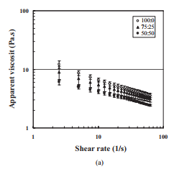

Cake Batter viscosity

<http://kasetsartjournal.ku.ac.th/kuj_files/2011/A1106211655184223.pdf>

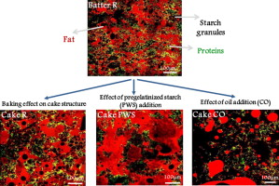

Cake Microstructure

<https://www.sciencedirect.com/science/article/pii/S221332911500009X>

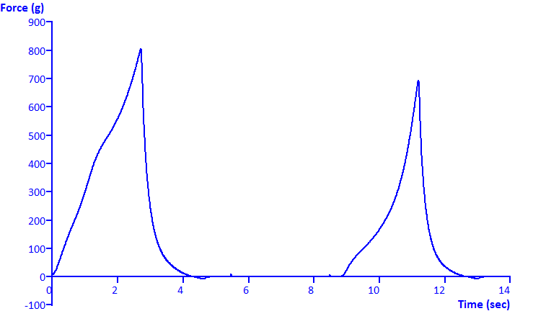

Cake Texture

<http://texturetechnologies.com/resources/texture-profile-analysis>

Cake Components

Cake batters are usually composed of flour, eggs, fat and sugar, and exhibit what is called viscoelastic behaviour, combining the properties of a fluid and a solid.

Each ingredient is essential in the batter, playing an important role in defining structural, rheological and textural properties of the cake. Mixing leads cake batter to be a stable emulsion of fat and water, that is sufficiently viscous to trap gas bubbles and retain them during baking.

During baking, the combined effect of usually wheat starch swelling and protein denaturation in presence of other ingredients transforms liquid batter into a solid foam (dough–crumb transition). The process of baking first significantly increases the batter viscosity before finally provide the firm structure of the foam matrix (continuous phase). Batter viscosity and density have an important role to play in influencing the final foam structure.

Today you will combine some qualitative and quantitative measures to determine whether it is better to use moderate protein levels, or higher protein levels in cake (or whether it makes no significant difference). The ingredients you will use are described below

***Wheat flour***

Wheat flour is a mixture of proteins and polysaccharides with a tiny amount of fat and minerals. The main polysaccharide present is starch, which has 2 main molecules, amylose and amylopectin. It is the amylose which helps ‘gel’ the batter and give it consistency. The main protein present in wheat flour is gluten. It is a complex structure and helps provide extra viscosity to cake batter.

***Sugar***

Sugar is a fairly simple molecule and is a dimer of fructose and glucose. It is typically used as a sweetener in many goods but in items like cake it also serves to add body and firmness to the structure, when baked/dried. Sugar also tends to brown when baked, giving most cakes their characteristic crust colour.

***Baking Powder***

Baking powder is simply a mixture of sodium bicarbonate and tartaric acid. It is termed a chemical leavening agent, which means it helps to aerate the batter by introducing a bubble structure. It is usually used in small amounts as too much tends to leave a strong ‘chemical’ taste.

***Milk***

Milk is used in baked products to improve texture and mouthfeel. The proteins present in milk also help give a soft crumb structure in cakes. Cakes that contain milk also tend to have a longer shelf life.

***Oil***

The main function of fat is to shorten or tenderise cake product. Other functions are to trap air during creaming and so aerate the cake during baking to give good volume and texture, and to help prevent curdling by forming an emulsion in the batter.

***Vanilla***

Vanilla is primarily present to add flavour to cakes. Most vanilla used is synthetic form as vanilla production worldwide is not sufficient to meet production needs.

Experiment 1: The effect of protein concentration on cake characteristics

**Aim**

To observe the effect of increased protein content on:

1. Ease of cake mixing
2. Cake bubble and crumb microstructure
3. Cake strength/texture

Density of different ingredients can be quite different and volume is not always the best measuring unit for dry ingredients. It is faster though. As you place each ingredient in the cup, tare the balance first and then weigh how much went in.

**Ingredients for the cake formulations**

|  |  |  |  |
| --- | --- | --- | --- |
| **Ingredient** | **Amount** | **Formulation 1 weight (g)** | **Formulation 2 weight (g)** |
| Flour (cake flour for formulation 1, bread flour for formulation 2 | 4 tablespoons |  |  |
| Sugar | 2 tablespoons |  |  |
| Baking powder | ½ a teaspoon |  |  |
| Milk | 4 tablespoons |  |  |
| Vanilla | ¼ teaspoon |  |  |
| Oil | 1 ½ tablespoons |  |  |

**Process:**

Cake Sample Preparation

1. Take 2 paper cups, Label the first as **Formulation 1** and the second as **Formulation 2**.
2. **For each of the 2 formulations:** Place the paper cup on the balance, tare the balance to zero, and add flour. Record flour weight in the table above. Tare the balance to zero again and add sugar. Record sugar weight. Finally tare the balance to zero again and add baking powder. Record baking powder weight.
3. Mix together the dry ingredients with a wooden popsicle stick
4. Now sequentially add the liquid ingredients, weighing with each addition. Tare the cup of dry ingredients on the balance to zero, and add milk. Record milk weight in the table above. Tare the balance to zero again and add vanilla. Record vanilla weight. Finally tare the balance to zero again and add oil. Record baking oil weight.
5. Mix together all the cake batter ingredients for 30 seconds with a popsicle stick. Use a different popsicle stick for each formulation. Which one is more difficult to mix – Formulation 1 with cake flour or Formulation 2 with bread flour? What could be the reason why?

**Most difficult to mix:**

**Reason why:**

1. Once the batter is mixed, measure the height from the top of the cup to the top of the batter for each formulation and record below. Also measure the full internal height of an empty paper cup for comparison and enter the value in the table below. Calculate and enter batter height.

|  |  |  |
| --- | --- | --- |
| **Initial Batter characteristic** | **Height from top to batter, HTB (cm)** | **Height of batter, HB =**  **HEC - HTB** |
| Formulation 1 |  |  |
| Formulation 2 |  |  |
| Empty cup full internal height, HEC |  | N/A |

1. Then cook 1 of the cakes in the microwave for 1 minute. Then cook the 2nd cake, also for 1 minute. Let cool for 1 minute.

You will now be performing some tests and measurements on the cakes to determine which flour might be giving the best cake, OR whether there are any significant differences.

Cake Testing

*Size increase from batter to cake*

1. Once the cakes are cooled, measure cake height in the same way batter height was measured. Calculate and enter cake height and height increase ratio.

|  |  |  |  |
| --- | --- | --- | --- |
| **Final Cake characteristic** | **Height from top to cake, HTC (cm)** | **Height of cake, HC =**  **HEC - HTB** | **Height increase ratio (HC/HB)** |
| Formulation 1 |  |  |  |
| Formulation 2 |  |  |  |
| Empty cup full internal height, HEC |  | N/A | N/A |

Height increase ratio can indicate which cake has more air incorporated.

A light airy texture is required for some cake types, while other cake types can be dense and heavy. In this regard, cake texture acceptability is more flexible than for wheat bread vs gluten free bread.

*Bubble size in cake*

Bubble size in cake is another measure and it can indicate how tender your cake might be. We will use a measuring app to determine bubble size in each cake.

**Please install ON 2D Cam Measure on your smartphone** (where possible)

1. First, remove your cake from the paper cup.
2. Slice the cake in half horizontally, and reserve half for texture testing
3. With the other half, take a 1 cm slice from the cake and place on a white piece of paper (the back of this document should be fine).
4. Place a measuring tape next to the slice of cake and using the measuring app take an image.
5. Calibrate the image against the measuring tape in the image.
6. Measure the diameter or area of some bubbles (zoom in if you need to)
7. If bubbles are difficult to see, measure crumbs that fell when you cut the cake. Record measurements in the table on the next page.

|  |  |  |
| --- | --- | --- |
| **Crumb/Bubble size** | **Formulation 1** | **Formulation 2** |
| 1 |  |  |
| 2 |  |  |
| 3 |  |  |
| 4 |  |  |
| 5 |  |  |
| 6 |  |  |

*Cake strength testing*

Physical texture of foods is often tested using a texture analyser, this consists of a vertically moving probe and a load cell. Forces are measured with a transducer and can tell you how firm the product is.

We are going to use known weights and do some calculations to determine cake strength/strain.

1. With the retained half of each of your cakes cut 2 cubes that are 2 cm x 2 cm x 2 cm. Try to be as precise as possible as these dimensions are needed for calculations.
2. Place one of the cubes on your chopping board and place the Large can on your cake. Record the ‘squashed’ height of your cake and use the image analysis app and measuring tape, measure the ‘squashed’ area of your cake.
3. With the 2nd cube, place it on the board and place the small can on your cake. Again record the ‘squashed’ height of your cake and use the image analysis app and measuring tape, measure the ‘squashed’ area of your cake.

|  |  |  |
| --- | --- | --- |
| **Strength test raw data** | **Formulation 1** | **Formulation 2** |
| Large can crush height |  |  |
| Small can crush height |  |  |
| Large can crush area |  |  |
| Small can crush area |  |  |

Finally you will do some coarse calculations to determine cake strength and compressibility.

First record the following:

**Large can weight:**

**Large can force (weight x 9.81):**

**Small can weight:**

**Small can force (weight x 9.81):**

Next determine the applied stress for both tests (analogous to strength testing of steel or concrete.

**Engineering Stress** = Force/Area (where force is from the can of choice, and area is initial exposed cake area – i.e. 2 cm x 2 cm). True stress is based on actual area at each stage of the test

|  |  |  |
| --- | --- | --- |
| **Strength test Stress (Pa)** | **Formulation 1** | **Formulation 2** |
| Large can Engineering Stress |  |  |
| Small can Engineering Stress |  |  |
| Large can true stress (at end) |  |  |
| Small can true stress (at end) |  |  |

Strain is a measure of how compressed/compressible your sample is

**Strain** = (initial height – final height)/initial height

|  |  |  |
| --- | --- | --- |
| **Strength test Strain (Pa)** | **Formulation 1** | **Formulation 2** |
| Large can Strain |  |  |
| Small can Strain |  |  |

**A lower stress and higher strain indicates a more tender cake.**

Lastly you will calculate the elastic or Young’s modulus of your cakes and compare them with other materials. Most materials are elastic at small strains.

Young’s modulus is calculated by the formula **Stress/Strain**

|  |  |  |
| --- | --- | --- |
| **Strength test Strain (Pa)** | **Formulation 1** | **Formulation 2** |
| Large Young’s Modulus |  |  |
| Small can Young’s Modulus |  |  |

Young’s Modulus of a range of materials can be found at <https://www.engineeringtoolbox.com/young-modulus-d_417.html> and are on the order of GPa.

What you have calculated here is only Pa.

The core difference between cake and engineered materials, is that engineered materials are built to last for a long time, whilst cake is engineered to be destroyed easily and last a short time.