|  |
| --- |
|  |
| BIO3810/BIO3820 Residential School Day 1  Experimental Booklet |
| Dr Polly Burey |

|  |
| --- |
|  |

Contents

List of Tables 1

Experiment 1: Effect of starter concentration on yoghurt consistency and viscosity 2

Background 2

Equipment 2

Procedure 2

Experiment 2: Fermentation of Cider 4

Background 4

Equipment 4

Procedure 4

Results 7

Experiment 3: Water activity and moisture content 15

Background 15

Equipment 15

Procedure 15

List of Tables

**Table 1**: **Weights for each of the fermenter bottles** 7

**Table 2: Initial Juice batch properties** 8

**Table 3: Ferment batch properties after 24 hours** 9

**Table 4: Alcohol % Analysis data based on CO2 production** 11

**Table 5: Alcohol % Analysis data based on Glucose expenditure** 13

**Table 6: Alcohol % Analysis data based on auto-calculation** 14

Experiment 1: Effect of starter concentration on yoghurt consistency and viscosity

Background

Yoghurt is an example of a fermented food and can be produced quite easily with a starter. The starter can come from a prior batch of yoghurt. The amount of starter can affect the pH and texture of the yoghurt. It is important to understand the magnitude of the effect to achieve the desired product.

Equipment

* Plastic or paper cups/containers
* Plain greek yoghurt
* Milk
* Spoons
* Scales
* Measuring cups

Procedure

A typical recipe uses a ratio of 1 litre of milk to 3 tablespoons of starter yoghurt.

1. Scale this down to 250 mL
   1. Note 1 metric tablespoon is 15 mL; it might be good to weigh the yoghurt to determine how much this is in grams as this may be easier to measure for ‘in-between’ amounts.
2. Select other ratios of milk to yoghurt so that you can observe the effect of starter concentration on yoghurt texture later.
3. Prepare 3 yoghurt samples with different starter amounts. One sample will have the starter amount recommended by the ratio above, one will have less and the other will have more.
4. Measure and record the pH of each yoghurt sample with immediately after inoculation of starter and at the end of incubation. For interest you may wish to test the pH of the milk as well.
5. Leave to incubate overnight, then place in the fridge until the Tuesday afternoon.
6. Observe the consistency of the yoghurt at the end of incubation and record the results. Evaluate the order of viscosity of the samples from thinnest to thickest.
7. Measure the viscosity of the samples using the Quickstart Instructions for the Viscometer shown on the following page.

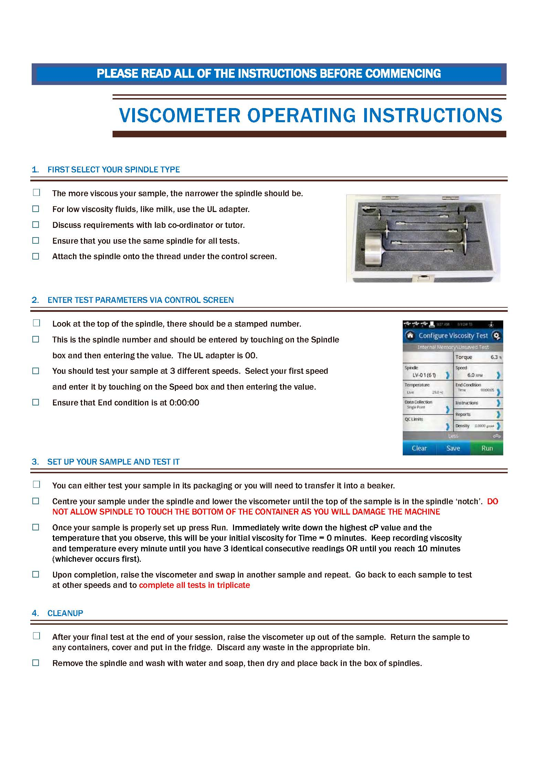

Experiment 2: Fermentation of Cider

Background

Fermentation is typically utilised to produce desirable foods through processes such as conversion of juice into wine, grains into beer, or carbohydrates into carbon dioxide to leaven bread. In this experiment, you will carry out ethanol fermentation, with the chemical reaction below:

Equipment

* Fermentation bottles with airlocks
* Brix refractometer
* Hydrometer
* Scales
* Apple corer
* Kettle
* Turbo Yeast (majority of fermentation completed in 24 hours)
* Juicer
* Apples
* Various commercial apple juices

Procedure

***Sterilisation Procedure***

1. Carefully fill a fermentation bottle about ¼ full with boiling water (**take care**)
2. Re-cap the bottle and shake up and down to coat the bottle with the boiling water.
3. Pour the boiling water out down the sink drain and re-cap the bottle until needed.
4. Weigh each empty bottle and record their weights.

***Juicing of apples***

1. Weigh the apples
2. Core the apples
3. Juice the apples with the juicer, observe all safe practice
   1. Do NOT place fingers or hands down the chute
   2. Hold the pusher on or close to the chute before starting
   3. Carefully place an apple in the chute and then push it down using the pusher.
   4. If anything untoward is occurring switch OFF the juicer at the wall.

***Pre-fermentation analysis of Apple Juice***

1. **Measure the Brix of the juice** using the Brix refractometer and record.
   1. **First calibrate the refractometer** by covering the cell in deionised water while the meter is turned off. Close the lid and power on the meter. Press and hold CAL for two seconds. Wipe the cell clean and dry
   2. While the meter is off, cover the glass cell with sample. Power the meter on, close the lid and and press ‘Read’. Record the result in the results section.
   3. Repeat 2 more times and then average the results.
   4. Compare to the sugar percentage on the nutrition label
2. ***Measure the specific gravity of the juice***
   1. Carefully pour some apple juice into the hydrometer storage tube.
   2. Carefully insert the hydrometer (**DON’T LET IT DROP!**) and let it settle.
   3. Read where the liquid level sits on the hydrometer scale and record initial specific gravity.

***Fermenter setup***

1. First weigh the empty fermenter bottle and record the weight.
2. You have several bottles to set up as fermenters to which you need to add 500 g of juice.
3. **Calculate how much sugar is in your juice samples.**
   1. Determine how much yeast is required for this amount of sugar for each juice.
   2. Once everyone’s calculations are done, use the highest amount of yeast calculated and place that amount in each bottle of juice.
   3. Do this by using the small scales to weigh the appropriate amount of yeast into a small plastic beaker. Then pour the yeast from the beaker into the bottle containing the juice.
4. Fit the lid complete with airlock to each bottle containing juice and fill the airlock with deionised water to the mark. Reassemble the airlock.
5. Weigh each bottle and record the weights.
6. Leave the bottles to primary ferment at room temperature (~20-25°C) for 24 hours.
7. The must might be cloudy, but it will clear up later.
8. After 24 hours re-measure everything
   1. **Re-weigh the bottles** and record – the difference in weight is approximately the amount of CO2 that has escaped.
   2. Collect samples and **re-measure Brix and specific gravity**.

**Note any Deviations from the Procedure or Anomalies that you observe:**

Results

***1 Initial Data***

**Table 1**: **Weights for each of the fermenter bottles**

|  |  |  |  |  |
| --- | --- | --- | --- | --- |
| **Bottle Number** | **1** | **2** | **3** | **4** |
| **Empty Bottle Weight without airlock (grams)** |  |  |  |  |
| **Juice Mass (grams)** |  |  |  |  |
| **Full bottle weight with airlock (grams)** |  |  |  |  |

**Table 2: Initial Juice batch properties**

|  |  |  |  |  |  |  |  |  |  |  |  |  |  |  |  |
| --- | --- | --- | --- | --- | --- | --- | --- | --- | --- | --- | --- | --- | --- | --- | --- |
|  | **Bottle Number** | | | | | | | | | | | | | | |
|  | **1** | | | **2** | | | **3** | | | **4** | | | **5** | | |
| **Brix of juice sample (°)** |  |  |  |  |  |  |  |  |  |  |  |  |  |  |  |
| ***Average Brix*** |  | | |  | | |  | | |  | | |  | | |
| **Specific gravity of sample (mL/g)** |  |  |  |  |  |  |  |  |  |  |  |  |  |  |  |
| ***Average S.G.*** |  | | |  | | |  | | |  | | |  | | |

***Notes:***

**Table 3: Ferment batch properties after 24 hours**

|  |  |  |  |  |  |  |  |  |  |  |  |  |  |  |  |
| --- | --- | --- | --- | --- | --- | --- | --- | --- | --- | --- | --- | --- | --- | --- | --- |
|  | **Bottle Number** | | | | | | | | |  | | |  | | |
|  | **1** | | | **2** | | | **3** | | | **4** | | | **5** | | |
| **Bottle weight (grams)** |  | | |  | | |  | | |  | | |  | | |
| **Brix of sample (°)** |  |  |  |  |  |  |  |  |  |  |  |  |  |  |  |
| ***Average Brix*** |  | | |  | | |  | | |  | | |  | | |
| **Specific gravity of sample (mL/g)** |  |  |  |  |  |  |  |  |  |  | | |  | | |
| ***Average S.G.*** |  | | |  | | |  | | |  | | |  | | |

***Notes:***

**Analysis of Results**

1. Before analysis, you must first write down the complete fermentation reaction with chemical formulas and balance it.
2. Using the balanced reaction, determine ethanol % in your cider using the 3 methods below.
   1. ***All mass loss is carbon dioxide***. Use the mol ratio between carbon dioxide and ethanol to determine the mols of ethanol and then determine the mass of ethanol. Use this mass to determine ethanol percentage.

**Table 4: Alcohol % Analysis data based on CO2 production**

|  |  |  |  |  |  |
| --- | --- | --- | --- | --- | --- |
| **Bottle Number** | **Masss of CO2 produced (g)** | **Mols of CO2 produced** | **Mols of ethanolproduced** | **Mass of ethanolproduced** | **Cider Alcohol % (final)** |
| 1 |  |  |  |  |  |
| 2 |  |  |  |  |  |
| 3 |  |  |  |  |  |
| 4 |  |  |  |  |  |
| 5 |  |  |  |  |  |

* 1. ***All the Brix loss is glucose being used up***. Use the mol. ratio between glucose and ethanol to determine the mols of ethanol and then determine it’s mass. Use this mass to determine ethanol percentage.

s

**Table 5: Alcohol % Analysis data based on Glucose expenditure**

|  |  |  |  |  |  |  |
| --- | --- | --- | --- | --- | --- | --- |
| **Bottle Number** | **Final Cider Mass** | **Mass of glucose reacted** | **Mols of glucosereacted** | **Mols of ethanolproduced** | **Mass of ethanol produced** | **Cider Alcohol % (final)** |
| 1 |  |  |  |  |  |  |
| 2 |  |  |  |  |  |  |
| 3 |  |  |  |  |  |  |
| 4 |  |  |  |  |  |  |
| 5 |  |  |  |  |  |  |

* 1. ***Use the Monitor Ferment from Refractometer Readings and Monitor Ferment from Hydrometer Readings calculator*** at <http://www.musther.net/vinocalc.html>

**Table 6: Alcohol % Analysis data based on auto-calculation**

|  |  |  |
| --- | --- | --- |
| **Bottle Number** | **Cider Alcohol % (final) from Refractometer** | **Cider Alcohol % (final) from Hydrometer** |
| 1 |  |  |
| 2 |  |  |
| 3 |  |  |
| 4 |  |  |
| 5 |  |  |

Experiment 3: Water activity and moisture content

***To fit in with today’s schedule we will only be preparing the tomato samples, they will all be tested on Day 2.***

Background

Moisture content and water activity are good indicators of shelf life with higher moisture content and water activity products having shorter shelf life. This is because a higher water availability along with some of the other components in food (e.g. sugar) make an ideal environment for microbial growth. In this experiment you will use some methods to measure these two parameters of samples ranging from tomato passata to tomato paste.

Equipment

* Square pans
* Scales
* Spoons
* Paper cups
* Microwave oven
* Oven set at 150°C
* Portable water activity meter.
* Passata

Procedure

***Preparation of Sample***

1. Weigh the empty square baking pan and record the weight________
2. Zero the scales with the square pan on top and pass the majority of the remaining passata through a sieve and weigh into the square baking pan.
3. Record tomato passata weight _____________

***Tomato concentration***

1. Place the square tray into the oven which will be set at 150°C. Stir with a spatula occasionally (about every 15 minutes) to prevent burn-on. Keep the tomatoes in an even layer.
2. At the end of the experiment, weigh all the tomato paste in the pan. Now you are ready to test some of its properties to check whether it meets standard requirements as per the codex attached – this will be done on Day 2.

***Water activity of Sample (to be done on Day 2)***

1. Measure water activity of the passata and tomato paste samples using the Aqualab Pawkit.
   1. Half fill the white plastic dish with the tomato sample. It is important you do not fill any higher.
   2. Uncover the cell on the underside of the Pawkit by pulling on the tab and flipping it to the other side.
   3. Carefully place the Pawkit meter over the top of the white dish ensuring it is flat.
   4. Press the blue button on the left-hand side of the meter. Ensure that the sun symbol starts flashing and the meter resets to zero.
   5. Wait until the meter beeps and record the measurement.

***Measure moisture of the sample by collecting sample for microwave oven drying.***

1. Weigh a paper cup accurately to 0.01g and record the weight_______
2. Add approximately 15 g of passata, smear it to a thin layer if possible and reweigh the cup and record weight_____________.
3. Place cup in the microwave and microwave on high for 10 seconds. Reweigh and record weight.
4. Repeat c) until the sample is constant weight before burning. Use the table below to keep track.

|  |  |  |
| --- | --- | --- |
| **Microwaving Time (s)** | **Weight of cup plus tomato sample (g)** | **Weight of tomato sample (g)** |
| **0** |  |  |
| **10** |  |  |
| **20** |  |  |
| **30** |  |  |
| **40** |  |  |
| **50** |  |  |
| **60** |  |  |
| **70** |  |  |
| **80** |  |  |
| **90** |  |  |
| **100** |  |  |

1. Determine moisture content as follows (should be ≈84-90%)

***=***

and check if it matches the answer calculated in Step e) above. Is this sufficient for the product to be a tomato paste? Will this deem the product suitable for longer-term storage?

***pH***

The pH of fruit and vegetable products in water or brine etc should be ‘no greater than 4.6’. Measure pH of the tomato products using guidance from your lecturer/lab supervisor. Does the tomato paste or passata meet the standard?