Activity 3 – Quality Measures

Practise of Quality Measures
Quality is about safety, but also consistency of products. Part of quality control and quality assurance is monitoring and maintaining this consistency.

- Measurement of Size and Shape
Using Vernier Calipers.
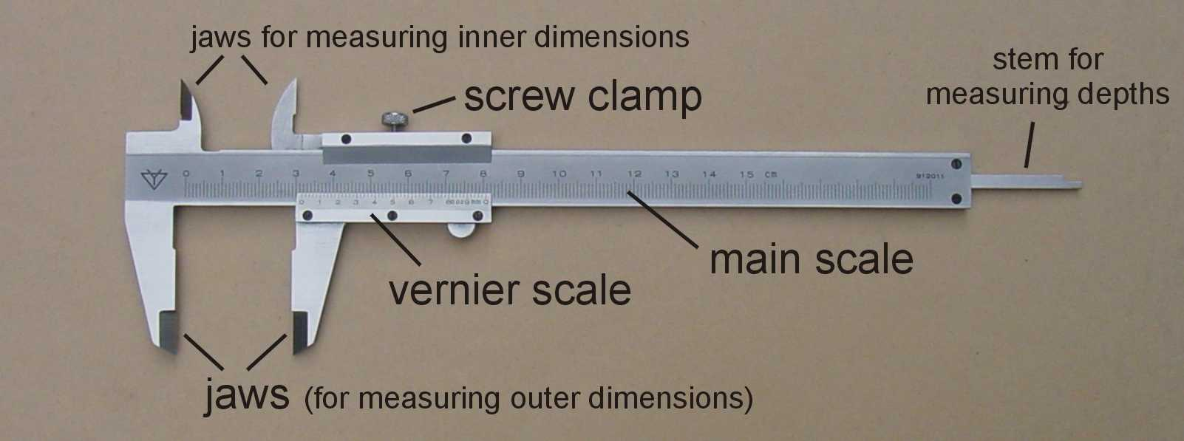
Reference: https://www.miniphysics.com/how-to-read-a-vernier-caliper.html
Many these days have a digital display as well so you may not always need to do manual reads. The link above is a good guide on how to use manual vernier calipers, but for digital ones the procedure basically involves a) zero-ing, aligning the object between the jaws and then taking the reading.
- Pick your food item and identify the primary ‘shape’. Typically, the foods may be cuboid, spherical or disc-shaped. (or random odd shapes).
- Measure the key dimensions – what would these be for each of the shapes above? Measure them at different points ‘around’ the shape. For e.g. a Tim Tam might be a cuboid – measure the thickness at different points along the Tim Tam. For an orange, measure the diameter at different points around the orange. Vernier calipers 14.09, 14.59, 14.35 (double coat Tim Tams seems to be smoother) Ruler standard Tim Tams coffee flavour 13mm, 12.5-13mm, 13 mm.
Notes: I may ask you to measure multiples of a type of item and then carry out statistical analysis – e.g. average and standard deviation. This may also be done with batches of rice grains or peas or other grain or leguminous items (a maximum of 20).

Please see attached ImageJ Analysis instructions if you will be using a ruler instead.

- Fault Analysis
This is an identification and count based exercise.
- Firstly, examine the packet for any faults with the packaging – considering labelling standards and any breaches of the packaging.
- Using a bulk packet of crackers, biscuits or nuts (limit to no more than 20) as an example, count the overall items – this could be sped up by weighing all of the items as batch, then weigh one individual item before calculating the number present.
- Another component could be comparing weight of the actual food in the package against the labelled amount. (see next task)
- Separate out and classify any ‘faults’. Carry out statistical analysis on the packet/batch.

- Checking against Package labels
This will involve comparing packet amount against what is labelled. We will use a multi-pack item for this exercise.
- This may involve a few small canned items or a box of muesli bars or a multipack box of chips/crackers. Tuna can example from Tayla – whole can weight = 127.32 grams – Can specifies 95 g of tuna – actual weight of (different scales) 99 grams. Tim Tams packed 160g – 18.73g, 19.58g, 18.5g. Double coat package is labelled as 200g
- Weigh each fully packaged item.
- Separate edible items from the package.
- Determine % of edible matter in the package.
- Compare to labelled package weights – typically if it’s over that’s ok – because a customer wouldn’t be unhappy, it’s when it’ underweight that it’s a problem.

- pH, water activity and Food safety
You will be using pH paper (at home) or pH probes and water activity meters (in USQ labs) to measure the properties of multiple items then evaluating their food safety. pH will be the core measure since this can be done anywhere (home or lab).
A good resource for the evaluation component is Chapter 3 of the FSANZ Food Standards code which outlines some pH limits (e.g. <4.6 for preserved fruits/vegetables and <3.5 for jam according to the Codex Alimentarius) and a_{w} limits for some foods - https://www.foodstandards.gov.au/code/Pages/default.aspx as well as the guide to the standards https://www.foodstandards.gov.au/publications/Documents/Safe%20Food%20Australia/FSANZ%20Safe%20Food%20Australia_WEB.pdf
Two stages of measurement.
Test the brine/syrup etc separately to the solids.
Then test the blended samples. Blend up the sample to provide a homogeneous sample of what is being tested and then measure pH.

